**Design for class “Cart”**

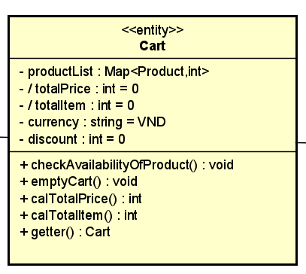

Figure 1: Design Class Diagram of Cart

Table 1: Attribute design of Cart

|  |  |  |  |  |
| --- | --- | --- | --- | --- |
|  | **Name** | **Data Type** | **Default value** | **Description** |
| 1 | productList | Map<Product, int> |  |  |
| 2 | totalPrice | int | 0 |  |
| 3 | totalItem | int | 0 |  |
| 4 | currency | int | VND |  |
| 5 | discount | int | 0 |  |

Table 2: Operation design of Cart

|  |  |  |  |
| --- | --- | --- | --- |
|  | **Name** | **Return Type** | **Description** |
| 1 | checkAvailabilityOfProduct() | void | Check if the quantity of products in cart is sufficient |
| 2 | emptyCart() |  | Delete all the products in cart |
| 3 | calTotalPrice() | int | Calculate the total price of products in cart |
| 4 | calTotalItem() | int | Calculate the total items in cart |
| 5 | getter() | Cart | The controller get the information about productList, totalItem, totalPrice, currency and discount to create the Order |

1. checkAvailabilityOfProduct()

**Exception**

|  |  |
| --- | --- |
| **Name** | **Description** |
| InsufficientStockException | Raised when there is not enough stock to fulfill the order. |
| EmptyCartException | Raised if cart is empty |

**Method**

|  |
| --- |
| public void checkAvailabilityOfProduct(int requestedQuantity) throws ProductUnavailableException, EmptyCartException {  checkIfEmpty(); // Check if the cart is empty  // Iterate through each item in the cart and check availability for the requested quantity  for (CartItem item : items) {  item.checkAvailabilityOfProduct(requestedQuantity); // Check for each product  }  } |

1. calTotalPrice ()

**Method**

|  |
| --- |
| public int calTotalPrice() {  int totalPrice = 0;  for (CartItem item : items) {  totalPrice += item.quantity * item.price; // Multiply quantity by price for each item and sum  }  return totalPrice;  } |

1. emptyCart ()

**Method**

|  |
| --- |
| public void emptyCart() {  items.clear(); // where items is a list of product and quantity  } |

1. calTotalItem ()

**Method**

|  |
| --- |
| public int calTotalItem() {  int totalItems = 0;  for (CartItem item : items) {  totalItems += item.quantity; // Sum the quantities of all items  }  return totalItems;  } |

**Design for class “Product”**

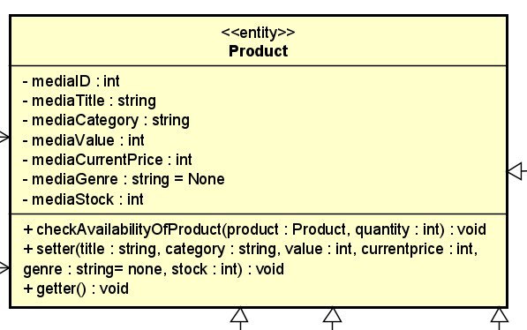

Figure 2: Design Class of Product

Table 3: Attribute design of Product

|  |  |  |  |  |
| --- | --- | --- | --- | --- |
| **#** | **Name** | **Data type** | **Default value** | **Description** |
| 1 | mediaID | int |  | Unique identifier for the product |
| 2 | mediaTitle | string |  | The name of the product |
| 3 | mediaValue | int |  |  |
| 4 | mediaCurrentPrice | int |  | The current price of product (VND) |
| 5 | mediaGenre | string | None | The list of product’s genres |
| 6 | mediaStock | int |  | The quantity of a particular product available in stock |
| 7 | mediaCategory | string |  | The category of product (DVD, LP, CD, book) |

Table 4: Operation design of Product

|  |  |  |  |
| --- | --- | --- | --- |
|  | **Name** | **Return Type** | **Description** |
| 1 | checkAvailabilityOfProduct() | boolean | Used to check if a product is available in stock |
| 2 | getter() | v.v | Used to retrieve the values of the attributes in the Product class |
| 3 | setter(...) | void | Used by Product Manager |

1. checkAvailabilityOfProduct()

**Parameter**

|  |  |  |
| --- | --- | --- |
| **Name** | **Default Value** | **Description** |
| Product |  |  |
| Quantity |  | The corresponding amount of chosen product |

**Exception**

|  |  |
| --- | --- |
| **Name** | **Description** |
| InsufficientStockException | Raised when there is not enough stock to fulfill the order. |

**Method**

|  |
| --- |
| Product product = products.get(productId);  if (product.mediaStock < quantity) {  throw new InsufficientStockException("Insufficient stock for product " + product.name + ". Available quantity: " + product.stock);  } |

1. setter ()

|  |  |  |
| --- | --- | --- |
| **Name** | **Default Value** | **Description** |
| mediaTitle |  | The name of the product |
| mediaValue |  |  |
| mediaCurrentPrice |  | The current price of product (VND) |
| mediaGenre | None | The list of product’s genres |
| mediaStock |  | The quantity of a particular product available in stock |
| mediaCategory |  | The category of product (DVD, LP, CD, book) |

**Method**

|  |
| --- |
| public setter(int mediaID, String mediaTitle, double mediaValue, double mediaCurrentPrice, String mediaGenre, int mediaStock, String mediaCategory) {  this.mediaID = mediaID;  this.mediaTitle = mediaTitle;  this.mediaValue = mediaValue;  this.mediaCurrentPrice = mediaCurrentPrice;  this.mediaGenre = mediaGenre;  this.mediaStock = mediaStock;  this.mediaCategory = mediaCategory;  } |

**Design for class “Order”**

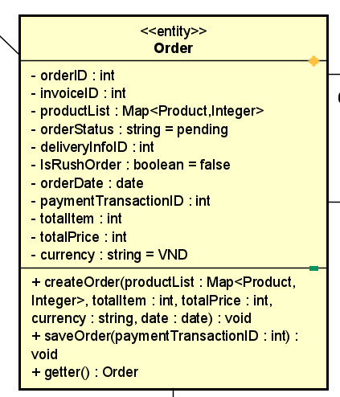

Figure 3: Design Class of Order

Table 5: Attribute design of Order

|  |  |  |  |  |
| --- | --- | --- | --- | --- |
|  | **Name** | **Data Type** | **Default value** | **Description** |
| 1 | orderID | int | N/A | Unique identifier for the order |
| 2 | invoiceID | int | N/A | The corresponding invoice |
| 3 | productList | Map<Product, int> | N/A | A list of media items associated with the order |
| 4 | isRushOrder | boolean | N/A | A flag indicating whether the order is a rush order (true or false) |
| 5 | orderStatus | char | N/A | Status of the order |
| 6 | deliveryInfoID | int | N/A | The corresponding delivery information ID |
| 7 | paymentTransactionID | int | N/A | The transaction ID used for refunds, if applicable |
| 8 | orderDate | date | N/A | The date when the order was placed |
| 9 | totalPrice | int |  |  |
| 10 | totalItems | int |  |  |
| 11 | curency | String |  |  |

Table 6: Operation design of Order

|  |  |  |  |
| --- | --- | --- | --- |
|  | **Name** | **Return Type** | **Description** |
| 1 | createOrder() | void | Used to retrieve the values of the attributes in the Product class |
| 2 | saveOrder() | void | Update the information about payment |
| 3 | getter() | void | Controllers get the information to create Invoice |

1. createOrder ()

**Parameter**

|  |  |  |
| --- | --- | --- |
| **Name** | **Default Value** | **Description** |
| productList |  | A list of media items associated with the order |
| currency |  |  |
| orderStatus | new | Status of the order |
| totalPrice |  |  |
| totalItems |  |  |
| orderDate |  | The date when the order was placed |

**Exception**

|  |  |
| --- | --- |
| **Name** | **Description** |
| NullPointerException | If productList, currency, or date is null |
| IllegalArgumentException | If totalItem or totalPrice is negative, |

**Method**

|  |
| --- |
| public void createOrder(Map<Product, Integer> productList, int totalItem, int totalPrice, String currency, Date date) {  if (productList == null || currency == null || date == null) {  throw new IllegalArgumentException("Product list, currency, and date must not be null");  }  if (totalItem < 0 || totalPrice < 0) {  throw new IllegalArgumentException("Total item and total price must be non-negative");  }    this.productList = productList;  this.totalItem = totalItem;  this.totalPrice = totalPrice;  this.currency = currency;  this.date = date;} |

1. saveOrder()

|  |  |  |
| --- | --- | --- |
| **Name** | **Default Value** | **Description** |
| paymentTransactionID |  | The payment transaction ID |

**Method**

|  |
| --- |
| public void saveOrder(int paymentTransactionID) {  this.paymentTransactionID = paymentTransactionID;  this.orderStatus = "Pending";} |

1. getter ()

**Method**

|  |
| --- |
| public Order getter() {  return this;  } |

**State Diagram of order**

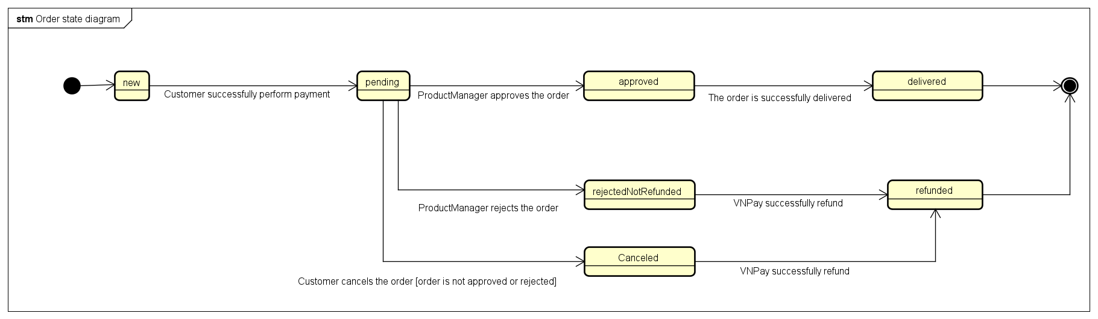

**Design for class “Invoice”**

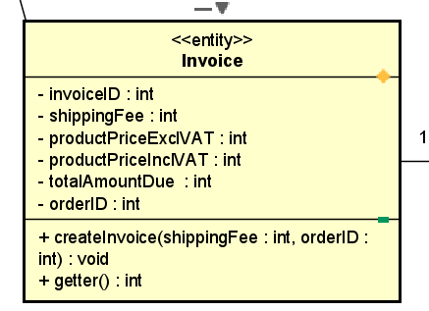

Figure 4: Design Class of Invoice

Table 7: Attribute design of Invoice

|  |  |  |  |  |
| --- | --- | --- | --- | --- |
|  | **Name** | **Data Type** | **Default value** | **Description** |
| 1 | invoiceID | int |  |  |
| 2 | shippingFee | Int |  | The delivery fee |
| 3 | productPriceExclVAT | int | 0 | The total price of products in order before VAT |
| 4 | productPriceInclVAT | int | 0 | The total price of products in order after VAT |
| 5 | totalAmountDue | Int | VND | The total amount that customer need to pay |
| 6 | orderID | int |  |  |

Table 8: Operation design of Invoice

|  |  |  |  |
| --- | --- | --- | --- |
|  | **Name** | **Return Type** | **Description** |
| 1 | createInvoice() | boolean | Controller creates new invoice |
| 2 | getter() | Invoice | Get the invoice information |

1. createInvoice()

**Parameter**

|  |  |  |
| --- | --- | --- |
| **Name** | **Default Value** | **Description** |
| shippingFee |  | Shipping fee calculate by controller |
| orderID |  | The corresponding order ID |

**Exception**

|  |  |
| --- | --- |
| **Name** | **Description** |
| IllegalArgumentException | If shipping fee or order ID is not valid |

**Method**

|  |
| --- |
| public void createInvoice(int shippingFee, int orderID) {  if (shippingFee < 0) {  throw new IllegalArgumentException("Shipping fee cannot be negative");  }  if (orderID <= 0) {  throw new IllegalArgumentException("Order ID must be a positive integer");  }    this.shippingFee = shippingFee;  this.orderID = orderID;} |

1. getter ()

**Method**

|  |
| --- |
| public int getter() {  return this.invoiceID;  } |

**Design for class “DeliveryInformation”**

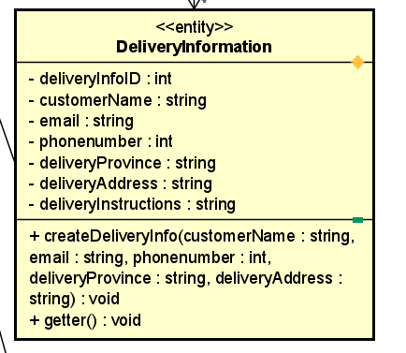

Figure 5: Design Class of DeliveryInformation

Table 9: Attribute design of DeliveryInformation

|  |  |  |  |  |
| --- | --- | --- | --- | --- |
|  | **Name** | **Data Type** | **Default value** | **Description** |
| 1 | deliveryInfoID | int |  |  |
| 2 | customerName | String |  |  |
| 3 | email | string | 0 |  |
| 4 | phonenumber | Int | VND |  |
| 5 | deliveryProvince | string | 0 |  |
| 6 | deliveryAddress | string |  |  |
| 7 | deliveryInstruction | string |  |  |

Table 10: Operation design of DeliveryInformation

|  |  |  |  |
| --- | --- | --- | --- |
|  | **Name** | **Return Type** | **Description** |
| 1 | createDeliveryInfo() | boolean | Create new delivery information |
| 2 | getter() | DeliveryInformation | The controller get the information about deliveryInformation |

1. createDeliveryInfo ()

**Parameter**

|  |  |  |
| --- | --- | --- |
| **Name** | **Default Value** | **Description** |
| customerName |  |  |
| email |  | The corresponding amount of chosen product |
| phonenumber |  |  |
| deliveryProvince |  |  |
| deliveryAddress |  |  |
| deliveryInstruction |  |  |

**Exception**

|  |  |
| --- | --- |
| **Name** | **Description** |
| IllegalArgumentException | If any input field is not valid |

**Method**

|  |
| --- |
| public boolean createDeliveryInfo(String customerName, String email, int phoneNumber, String deliveryProvince, String deliveryAddress, String deliveryInstruction) {  if (customerName == null || customerName.isEmpty()) {  throw new IllegalArgumentException("Customer name cannot be null or empty");  }  if (email == null || email.isEmpty()) {  throw new IllegalArgumentException("Email cannot be null or empty");  }  if (phoneNumber <= 0) {  throw new IllegalArgumentException("Phone number must be a positive integer");  }  if (deliveryProvince == null || deliveryProvince.isEmpty()) {  throw new IllegalArgumentException("Delivery province cannot be null or empty");  }  if (deliveryAddress == null || deliveryAddress.isEmpty()) {  throw new IllegalArgumentException("Delivery address cannot be null or empty");  }  } |

1. getter ()

**Method**

|  |
| --- |
| public int getter() {  return this.deliveryInfoID;  } |

**Design for class “PlaceOrderController”**

Figure 6: Design Class of PlaceOrderController

Table 11: Attribute design of PlaceOrderController

|  |  |  |  |  |
| --- | --- | --- | --- | --- |
|  | **Name** | **Data Type** | **Default value** | **Description** |
| 1 | shippingFee | int |  | The controller need to recalculate and save the shipping fee before creating the invoice |

Table 12: Operation design of PlaceOrderController

|  |  |  |  |
| --- | --- | --- | --- |
|  | **Name** | **Return Type** | **Description** |
| 1 | requestToPlaceOrder () | void | Create new delivery information |
| 2 | submitDeliveryInfo () | void | The controller get the information about deliveryInformation |
| 3 | checkValidityofDeliveryInfo() | void | Check the validity of delivery information |
| 4 | calculateShippingFee() | int | Calculate shipping fee based on submitted addre |
| 5 | sendSuccessfullEmail() | void | Send email to customer after place an order successfully |
| 6 | placeOrder() | void | Call to saveOrder method |

1. requestToPlaceOrder ()

**Parameter**

|  |  |  |
| --- | --- | --- |
| **Name** | **Default Value** | **Description** |
| cart |  |  |

**Exception**

|  |  |
| --- | --- |
| **Name** | **Description** |
| IllegalArgumentException | If any input field is not valid |
| InsufficientStockException | If any products is insufficient |

**Method**

|  |
| --- |
| public void requestToPlaceOrder(Cart cart) throws InsufficientStockException {  checkAvailabilityOfProduct(cart);  } |

1. submitDeliveryInfo ()

**Exception**

|  |  |
| --- | --- |
| **Name** | **Description** |
| IllegalArgumentException | If any input field is not valid |

**Method**

|  |
| --- |
| public void submitDeliveryInfo(DeliveryInformation deliveryInfo) {  if (deliveryInfo == null) {  throw new IllegalArgumentException("Delivery information cannot be null");  }    if (checkValidityOfDeliveryInfo(deliveryInfo)) {  deliveryInfo.createDeliveryInfo(  deliveryInfo.getCustomerName(),  deliveryInfo.getEmail(),  deliveryInfo.getPhoneNumber(),  deliveryInfo.getDeliveryProvince(),  deliveryInfo.getDeliveryAddress(),  deliveryInfo.getDeliveryInstruction()  );  } |

1. checkValidityofDeliveryInfo ()

**Method**

|  |
| --- |
| private boolean checkValidityOfDeliveryInfo(DeliveryInformation deliveryInfo) {  return true; // Placeholder return value  } |

1. calculateShippingFee ()

|  |  |  |
| --- | --- | --- |
| **Name** | **Default Value** | **Description** |
| address |  |  |

1. placeOrder ()

**Exception**

|  |  |
| --- | --- |
| **Name** | **Description** |
| IllegalArgumentException | If any input field is not valid |

**Method**

|  |
| --- |
| public void placeOrder(Order order, int paymentTransactionID) {  if (order == null) {  throw new IllegalArgumentException("Order cannot be null");  }  if (paymentTransactionID <= 0) {  throw new IllegalArgumentException("Payment transaction ID must be positive");  }    order.saveOrder(paymentTransactionID);  } |

**Design for class “OrderInformationScreen”**

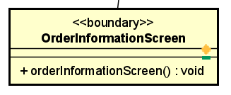

Figure 7: Design Class of OrderInformationScreen

Table 13: Operation design of OrderInformationScreen

|  |  |  |  |
| --- | --- | --- | --- |
|  | **Name** | **Return Type** | **Description** |
| 1 | orderInformationScreen() | void | Display all the related information about order |

1. orderInformationScreen ()

**Parameter**

|  |  |  |
| --- | --- | --- |
| **Name** | **Default Value** | **Description** |
| order |  |  |

**Exception**

|  |  |
| --- | --- |
| **Name** | **Description** |
| IllegalArgumentException | If any input field is not valid |

**Method**

|  |
| --- |
| : Operation design of Cart |

**Design for class “DeliveryInfoScreen”**

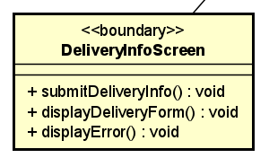

Figure 8: Design Class of DeliveryInfoScreen

Table 14: Operation design of DeliveryInfoScreen

|  |  |  |  |
| --- | --- | --- | --- |
|  | **Name** | **Return Type** | **Description** |
| 1 | submitDeliveryInfo () | void | User submit the information |
| 2 | displayDeliveryForm() | void | Display the delivery information form |
| 3 | displayError() | void |  |

1. displayError ()

**Method**

|  |
| --- |
| public void displayError () {  try {  controller.checkValidityofDeliveryInfo();  } catch (Exception e) {  System.out.println("Unmet Information: " + e.getMessage());  }  } |

**Design for class “DeliveryInfoScreen”**

Figure 8: Design Class of DeliveryInfoScreen

Table 14: Operation design of DeliveryInfoScreen

|  |  |  |  |
| --- | --- | --- | --- |
|  | **Name** | **Return Type** | **Description** |
| 1 | submitDeliveryInfo () | void | User submit the information |
| 2 | displayDeliveryForm() | void | Display the delivery information form |
| 3 | displayError() | void |  |

1. displayError ()

**Method**

|  |
| --- |
| public void displayError () {  try {  controller.checkValidityofDeliveryInfo();  } catch (Exception e) {  System.out.println("Unmet Information: " + e.getMessage());  }  } |

**Design for class “DeliveryInfoScreen”**

Figure 8: Design Class of DeliveryInfoScreen

Table 14: Operation design of DeliveryInfoScreen

|  |  |  |  |
| --- | --- | --- | --- |
|  | **Name** | **Return Type** | **Description** |
| 1 | submitDeliveryInfo () | void | User submit the information |
| 2 | displayDeliveryForm() | void | Display the delivery information form |
| 3 | displayError() | void |  |

1. displayError ()

**Method**

|  |
| --- |
| public void displayError () {  try {  controller.checkValidityofDeliveryInfo();  } catch (Exception e) {  System.out.println("Unmet Information: " + e.getMessage());  }  } |

**Design for class “DeliveryInfoScreen”**

Figure 8: Design Class of DeliveryInfoScreen

Table 14: Operation design of DeliveryInfoScreen

|  |  |  |  |
| --- | --- | --- | --- |
|  | **Name** | **Return Type** | **Description** |
| 1 | submitDeliveryInfo () | void | User submit the information |
| 2 | displayDeliveryForm() | void | Display the delivery information form |
| 3 | displayError() | void |  |

1. displayError ()

**Method**

|  |
| --- |
| public void displayError () {  try {  controller.checkValidityofDeliveryInfo();  } catch (Exception e) {  System.out.println("Unmet Information: " + e.getMessage());  }  } |

**Design for class “InvoiceScreen”**

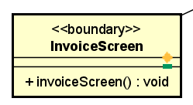

Figure 9: Design Class of InvoiceScreen

Table 15: Operation design of InvoiceScreen

|  |  |  |  |
| --- | --- | --- | --- |
|  | **Name** | **Return Type** | **Description** |
| 1 | invoiceScreen() | void | Redirect customer to payment method |

**Design for class “CartScreen”**

Figure 10: Design Class of CartScreen

Table 16: Operation design of CartScreen

|  |  |  |  |
| --- | --- | --- | --- |
|  | **Name** | **Return Type** | **Description** |
| 1 | requestToPlaceOrder () | void | Send to submitted information from user to controller |
| 2 | displayUnmetInformation() | void | Display unmet information for user if any product is insufficient |

1. displayUnmetInformation()

**Method**

|  |
| --- |
| public void displayUnmetInformation(Cart cart) {  try {  controller.requestToPlaceOrder(cart);  System.out.println("All products are available.");  } catch (InsufficientStockException e) {  System.out.println("Unmet Information: " + e.getMessage());  }  } |